Stage 3 – "I’d buy that for a dollar"
COURSE DESIGNER: Ike Starnes (Blue Team Shooting Sports)
SCORING: Comstock 29 rounds.
TARGETS: 13 cardboard targets, 3 steel targets.
SCORED HITS: 2 Best hits per carboard will be scored.

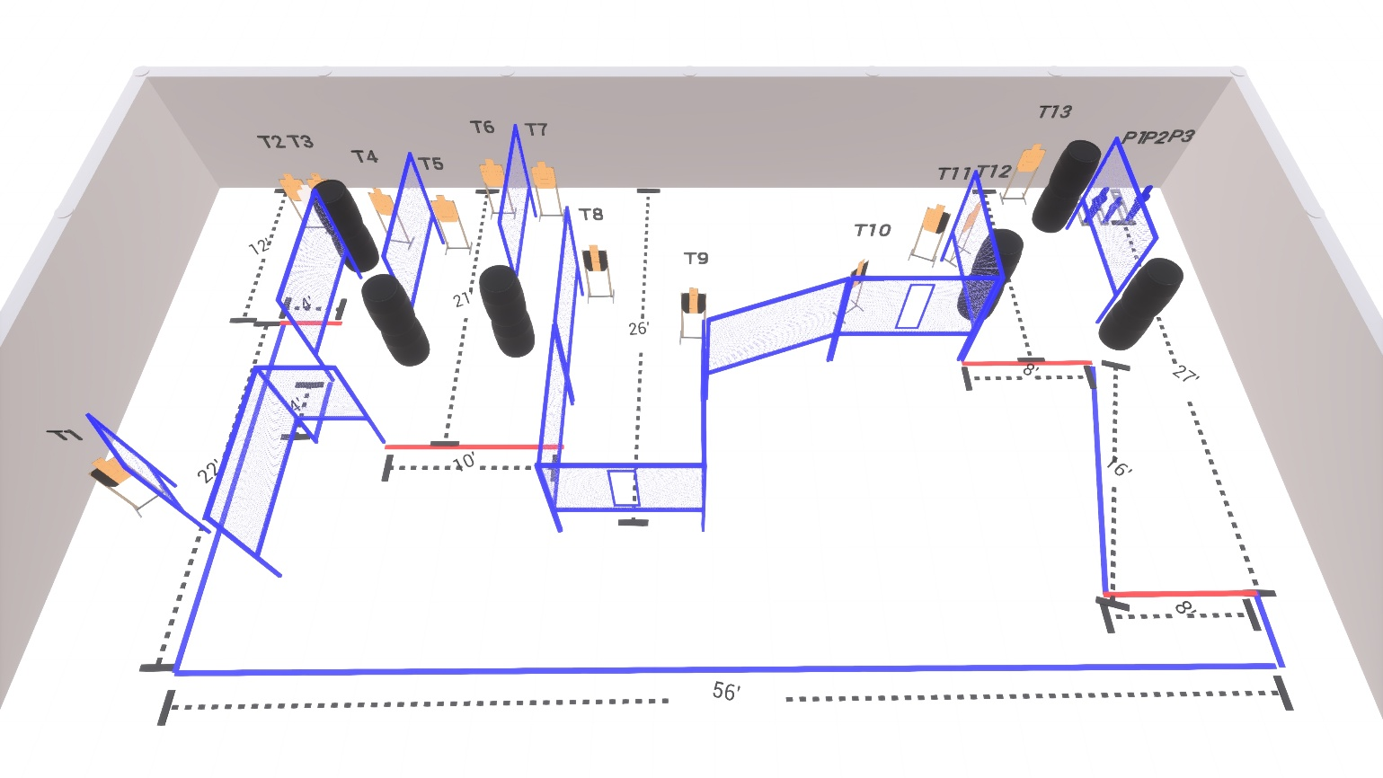

Written Stage Briefing:

Stage 3 – "I’d buy that for a dollar" - is a 29 round, 145 point, Comstock Course. There are 13 cardboard targets and 3 steel targets.

Starting with toes of both feet touching any red fault line.
Handgun is loaded and holstered, wrists below belt.
PCC is loaded held in both hands, stock on belt.

On the audible start signal, engage targets from within the shooting area.

USPSA / NROI Range Commands:
- Make Ready
- Are you ready?
- Standby
- If finished, unload and show clear
- If clear, hammer down and holster (Handgun)
If clear, hammer down and flag (PCC)
If clear, cylinder closed and holster (Revolver)
- Range is clear

Setup Notes:
14 Single Wall Stands
7 Double Wall Stands
11 Full Walls
2 Port Wall
13 Target stands / 26 target sticks
2 large poppers + bases
1 small popper + base
12+ Barrels



